**Redacting Sensitive Data with the DLP API**

experimentLabschedule1 houruniversal_currency_alt1 Creditshow_chartIntroductory

infoThis lab may incorporate AI tools to support your learning.

**Overview**

In this lab, you will set up the [Cloud Data Loss Prevention API (DLP API)](https://cloud.google.com/dlp/docs#docs) and use the API to inspect a string of data for sensitive information. The DLP API helps you better understand and manage sensitive data.

It provides fast, scalable classification and redaction for sensitive data elements like credit card numbers, names, social security numbers, US and selected international identifier numbers, phone numbers and Google Cloud credentials.

Objectives

In this lab, you will learn how to do the following:

* Enable the DLP API.
* Install the Node JS DLP API and sample.
* Inspect string data for sensitive data.
* Redact sensitive data from string data and images.

**Setup and requirements**

For each lab, you get a new Google Cloud project and set of resources for a fixed time at no cost.

1. Sign in to Qwiklabs using an **incognito window**.
2. Note the lab's access time (for example, 1:15:00), and make sure you can finish within that time.  
   There is no pause feature. You can restart if needed, but you have to start at the beginning.
3. When ready, click **Start lab**.
4. Note your lab credentials (**Username** and **Password**). You will use them to sign in to the Google Cloud Console.
5. Click **Open Google Console**.
6. Click **Use another account** and copy/paste credentials for **this** lab into the prompts.  
   If you use other credentials, you'll receive errors or **incur charges**.
7. Accept the terms and skip the recovery resource page.

**Note:** Do not click **End Lab** unless you have finished the lab or want to restart it. This clears your work and removes the project.

**Task 1. Enable the DLP API**

In this task, you enable the DLP API through APIs & Services.

1. Go to **Navigation menu > APIs & Services**.
2. Click the **Enable APIs and Services** button.
3. In the **Search for APIs & Services** field, enter DLP and then click on the **Cloud Data Loss Prevention (DLP) API** title.

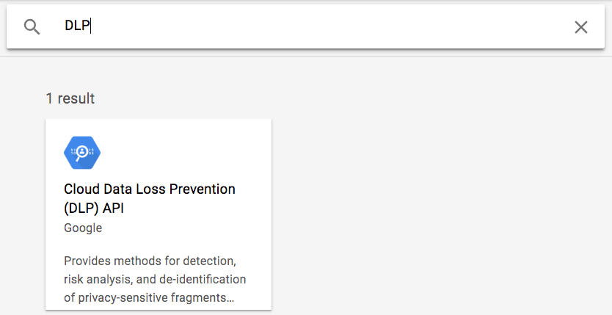

1. Click the **Enable** button to enable the DLP API. If the API is already enabled, you will see a **Manage** button instead, along with an *API enabled* message. In that case you do not need to do anything.

**Task 2. Install the DLP API and Node JS samples**

In this task, you download the Node JS DLP API and samples and install the required dependencies.

1. On the Google Cloud Console tile bar, click **Activate Cloud Shell** (Activate Cloud Shell icon) to open Cloud Shell. When prompted, click **Continue**. After a moment, in the lower part of the browser window, the Terminal appears.
2. Run the following command to create the GCLOUD_PROJECT environment variable and set it to the project ID:

export GCLOUD_PROJECT=$DEVSHELL_PROJECT_ID

Copied!

content_copy

1. Run the following command in Cloud Shell to download the Node JS DLP API and samples:

git clone https://github.com/GoogleCloudPlatform/nodejs-docs-samples

Copied!

content_copy

1. Once the download is complete, change into the **nodejs-docs-samples/dlp** directory:

cd nodejs-docs-samples/dlp

Copied!

content_copy

There are several Node JS DLP sample programs in this folder. Before you run them, you need to install the dependencies.

1. Run the following command to install the required dependencies:

npm install @google-cloud/dlp

npm install yargs

npm install mime@2.5.2

Copied!

content_copy

**Task 3. Inspect and redact sensitive data**

In this task, you inspect and mask sensitive information from the string also use the DLP API to redact sensitive data from an image.

Inspect a string for sensitive information

1. In Cloud Shell run the command below. (If prompted, click **Authorize**.)

node inspectString.js $GCLOUD_PROJECT "My email address is joe@example.com."

Copied!

content_copy

You should receive the following output.

**Output:**

Findings:

Info type: EMAIL_ADDRESS

Likelihood: LIKELY

The result shows what sensitive data was found, what type of information it is, and how certain the API is about that info type.

1. In Cloud Shell, run the following command:

node inspectString.js $GCLOUD_PROJECT "My phone number is 555-555-5555."

Copied!

content_copy

You should receive the following output.

**Output:**

Findings:

Info type: PHONE_NUMBER

Likelihood: VERY_LIKELY

1. Feel free to experiment with different input to the **inspectString.js** program. For example, try passing in values like 1234-5678-9876-5432 or 123-45-6789.

Mask sensitive information from a string

* In Cloud Shell, run the following command:

node deidentifyWithMask.js $GCLOUD_PROJECT "My phone number is 555-555-5555."

Copied!

content_copy

You should receive the following output.

**Output:**

My phone number is ************.

Redact sensitive data from images

You will now use the DLP API to redact sensitive data from an image.

1. Right-click on the image below and select **Save image as**. Save it locally on your computer as dlp-input.png.

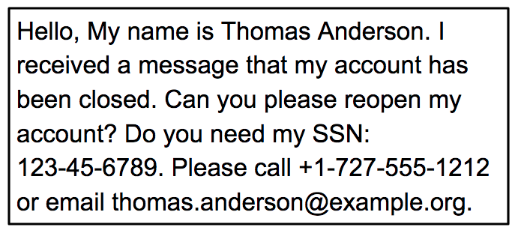

1. In the bar above the terminal, click the button at the top right with three vertical dots and select **Upload**.

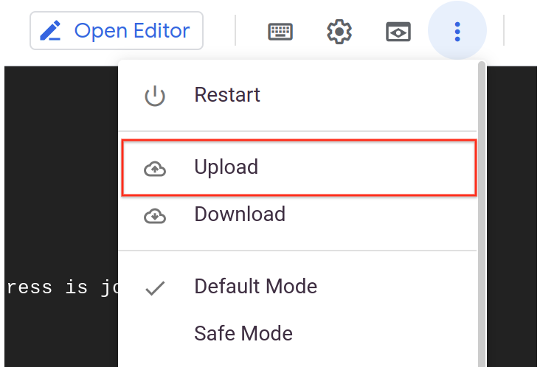

If **Upload** is not clickable ("grayed out"), then click **Restart**. After the Cloud Shell environment is restarted, the **Upload** Link should be active.

Execute these commands commands before starting the next step in the lab.

export GCLOUD_PROJECT=$DEVSHELL_PROJECT_ID

Copied!

content_copy

1. Click **Choose Files**, select the downloaded **dlp-input.png** image file, and **Upload** it to Cloud Shell.
2. From **Cloud Shell**, click **Open Editor** . This will launch the Cloud Shell code editor, which includes a file browser.
3. In the Cloud Shell code editor, on the left, you should see the **dlp-input.png** file.
4. Click the **dlp-input.png** file to display the image and verify it was uploaded.
5. From **Cloud Shell**, click **Open Terminal** to return to the terminal window.
6. In the terminal, run the following command to redact the email address values from the image:

node redactImage.js $GCLOUD_PROJECT ~/dlp-input.png "" EMAIL_ADDRESS ~/dlp-redacted.png

Copied!

content_copy

1. Open **Editor**.
2. In the Cloud Shell code editor, on the left, click the **dlp-redacted.png** file.

You will see the image with the domain name redacted.

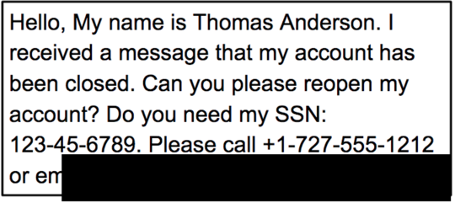

When calling the redact API, you specified EMAIL_ADDRESS as the infotype to redact. In the image, you should notice that the email address is no longer visible.

**Congratulations!**

In this lab, you did the following:

* Enabled the DLP API.
* Installed the Node JS DLP API, and sample.
* Inspected string data for sensitive data.
* Redacted sensitive data from string data and images.

**End your lab**

When you have completed your lab, click **End Lab**. Google Cloud Skills Boost removes the resources you’ve used and cleans the account for you.

You will be given an opportunity to rate the lab experience. Select the applicable number of stars, type a comment, and then click **Submit**.

The number of stars indicates the following:

* 1 star = Very dissatisfied
* 2 stars = Dissatisfied
* 3 stars = Neutral
* 4 stars = Satisfied
* 5 stars = Very satisfied

You can close the dialog box if you don't want to provide feedback.

For feedback, suggestions, or corrections, please use the **Support** tab.

Copyright 2022 Google LLC All rights reserved. Google and the Google logo are trademarks of Google LLC. All other company and product names may be trademarks of the respective companies with which they are associated.